**8 SCIENCE 2016**

### PHYSICS TEST TWO

Name: ____________________ Teacher: ___________________ Mark: /47

**Percentage: %**

**SECTION A: MULTIPLE CHOICE (20 marks)**

**Please circle your answer on the multiple choice answer grid below.**

1. A B C D 11. A B C D

2. A B C D 12. A B C D

3. A B C D 13. A B C D

4. A B C D 14. A B C D

5. A B C D 15. A B C D

6. A B C D 16. A B C D

7. A B C D 17. A B C D

8. A B C D 18. A B C D

9. A B C D 19. A B C D

10. A B C D 20. A B C D

**1.** Energy is measured using a unit called the:

(a) kilogram.

(b) metre.

(c) second.

(d) joule.

**2.** Select which of the following require energy to happen.

(a) Running in a race

(b) A leaf falling from a tree

(c) Clothes drying in the sun

(d) All of the above

**3.** The energy of a moving object is called:

(a) Nuclear energy.

(b) Gravitational potential energy.

(c) Elastic potential energy.

(d) Kinetic energy.

**4.** Jordan watches a music video clip on his iPhone. Choose the best description of the energy transformations that are happening.

(a) electrical energy 🡪 sound energy + light energy + heat energy

(b) electrical energy 🡪 sound energy + light energy

(c) sound energy + light energy + heat energy 🡪 electrical energy

(d) sound energy + light energy 🡪 electrical energy

**5.** The correct definition for energy efficiency is:

(a) A measure of how much input energy is converted into wasted energy.

(b) A measure of how much input energy is converted into useful energy.

(c) When an appliance wastes different forms of energy.

(d) When an appliance uses many types of energy.

**6.** The number of stars found on an Energy Rating Label indicate:

(a) The energy efficiency of an appliance.

(b) How much energy the appliance will require to operate.

(c) How much effort needs to be taken to maintain the appliance.

(d) How easy the appliance is to clean.

**7.** Select which of the following contains elastic potential energy.

(a) A stretched bow about to fire an arrow.

(b) A tree branch.

(c) A seagull in flight.

(d) An apple.

**8.** Select which device transforms chemical energy into kinetic energy.

(a) A torch.

(b) A battery operated car.

(c) A kettle.

(d) An electric knife.

**9.** Photosynthesis converts sunlight into what energy type?

(a) Electrical energy.

(b) Kinetic energy.

(c) Chemical energy.

(d) Potential energy.

**10.** Select the correct energy flow diagram showing energy changes that occur when operating a battery-operated fire truck that moves and sounds a siren.

(a) Electrical energy 🡪 chemical energy + sound energy

(b) Chemical energy 🡪 sound + heat energy

(c) Electrical energy 🡪 heat + elastic potential energy

(d) Chemical energy 🡪 kinetic energy + sound + heat

**11.** The efficiency of three different washing machines are as follows:

Spinners washing machine is 40% energy efficient.

Sparkles washing machine is 35% energy efficient.

Sprinkles washing machine is 52% energy efficient.

The machines listed from most to least energy efficient are:

(a) Spinners, Sparkles, Sprinkles.

(b) Sparkles, Sprinkles, Spinners.

(c) Sprinkles, Spinners, Sparkles.

(d) Sparkles, Spinners, Sprinkles.

**12.** What does the prefix mega mean?

(a) One hundred.

(b) One thousand.

(c) One thousandth.

(d) One million.

**13.** Which of the following is an example of energy efficiency (as opposed to reducing consumption).

(a) Only having the TV or the ipad on, not both.

(b) Having insulation installed in a house.

(c) Turning the lights off when leaving a room.

(d) All of the above.

**14.** Energy cannot be created or destroyed. This is known as:

(a) Energy Efficiency.

(b) Newtons Law.

(c) The Law of conservation of energy.

(d) A force of nature.

**15.** How many joules in a kilojoule?

(a) 10.

(b) 100.

(c) 1000.

(d) 10000.

**16.** Whenever an object is shifted or changes shape, work has been done. Select the situation below in which work has been done on an object:

(a) A cat sits on a rug.

(b) Ben lifts his dog’s food dish.

(c) Sunlight shines on a parked car.

(d) Music plays from a radio.

**[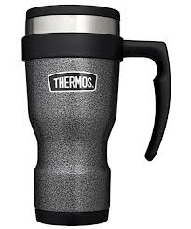](http://www.google.com.au/imgres?hl=en&biw=1920&bih=931&tbm=isch&tbnid=rELzCzmWGMl_FM:&imgrefurl=http://www.outdoorandcountry.co.uk/Thermos-Flask-e28093-Stainless-King-Travel-Mug-Hammertone-450ml.html&docid=jT__EPlCarbg2M&imgurl=http://www.outdoorandcountry.co.uk/userimages/productstyles/product_large/0078490000000.jpg&w=1000&h=1200&ei=2b5CUf_sMdDYkQW5kYDIDA&zoom=1&sa=X&ved=0CMICEIQcMEk&ved=1t:3588,r:73,s:0,i:322&iact=rc&dur=1501&page=2&tbnh=178&tbnw=142&start=40&ndsp=50&tx=76&ty=124)17.** An effective insulator traps heat energy. The effectiveness of three brands of thermos mugs are shown below. An equal volume of water at 80°C was poured into each thermos. The temperature of the water was tested every 10 minutes. These temperatures in each thermos are shown in the table below.

|  |  |  |  |  |
| --- | --- | --- | --- | --- |
| Time (mins) | Silvertop thermos | Geyser thermos | Thermocool thermos | Radiant thermos |
| 0 | 80 | 80 | 80 | 80 |
| 10 | 72 | 80 | 68 | 79 |
| 20 | 65 | 77 | 55 | 78 |
| 30 | 57 | 76 | 48 | 77 |
| 40 | 54 | 76 | 41 | 76 |
| 50 | 52 | 75 | 36 | 73 |
| 60 | 49 | 75 | 34 | 66 |

The most effective insulator is the:

(a) Silvertop thermos.

(b) Geyser thermos.

(c) Thermocool thermos.

(d) Radiant thermos.

**18.** Energy stored inside an atom is known as:

(a) Atom energy.

(b) Nuclear energy.

(c) Nucleus energy.

(d) Chemical energy.

**19.** Types of potential energy include:

(a) Heat energy, chemical potential energy, gravitational potential energy.

(b) Elastic potential energy, chemical energy, gravitational potential energy.

(c) Elastic potential energy, light energy, gravitational potential energy.

(d) Chemical energy, gravitational potential energy, kinetic energy.

**20.** Select the most correct definition for the term ‘energy efficiency’.

(a) A measure of how much input energy is converted to useful output energy.

(b) A measure of how much output energy is converted to useful input energy.

(c) A measure of how much energy is used during an energy transfer.

(d) A measure of how much energy is wasted during an energy transformation.

**SECTION B: SHORT ANSWER (27 marks)**

**21.** A red Honda travels at 20 km/h around a curved road near the top of a mountain. A blue Honda travels at 50 km/h along a flat road near a beach.

(a) State which car has the greatest kinetic energy. (1 mark)

________________________________________________

(b) Explain your answer to part (a). (2 marks)

___________________________________________________________________________

___________________________________________________________________________

___________________________________________________________________________

___________________________________________________________________________

___________________________________________________________________________

**22.** Explain the difference between energy transfer and energy transformation. (2 marks)

_________________________________________________________________________________

_________________________________________________________________________________

_________________________________________________________________________________

_________________________________________________________________________________

_________________________________________________________________________________

_________________________________________________________________________________

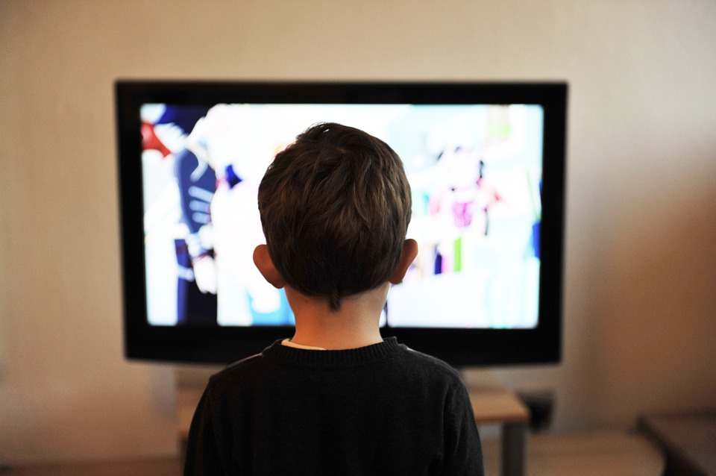**23.** Michael watches a television show after school.

(a) State the source of energy for the television. (1 mark)

_________________________________________

(b) List three forms of energy that this energy is transformed into. (3 marks)

________________________ ________________________ ________________________

(c) Can a television can be 100% efficient? (Circle the correct response). (1 mark)

YES NO

(d) Explain your response from part (c). (2 marks)

___________________________________________________________________________

___________________________________________________________________________

___________________________________________________________________________

___________________________________________________________________________

___________________________________________________________________________

**24.** Write the corresponding letter in each box below to match the situation to its energy flow diagram.

(6 marks)

(a) A solar light turns on.

(b) Luke dives into a pool from the edge of a diving board.

(c) A plant undergoes the process of photosynthesis.

(d) A battery operated mouse rolls along the floor.

(e) Maia eats a sandwich then goes for a run.

(f) An empty pot is heated on an electric stove.

Chemical energy 🡪 kinetic energy

Gravitational potential energy 🡪 kinetic energy + sound energy + heat energy

Electrical energy 🡪 heat energy

Light energy 🡪 chemical energy

Chemical energy 🡪 electrical energy 🡪 kinetic energy + sound energy + heat energy

Light energy 🡪 electrical energy 🡪 light energy + heat energy

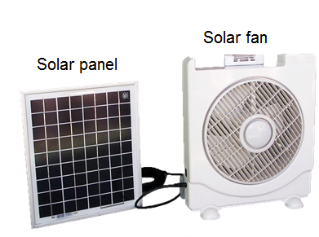**25.** This image shows a solar panel that is used to operate a solar fan. (3 marks)

Draw an energy flow diagram to show the energy changes that take place in this process.

**26.** Some students investigated the effect of colour on the ability of a container to radiate heat. They painted two identical tin cans. One was painted blue and the other yellow. Each was filled with 50 mL of hot water at 80°C and the temperatures were recorded every minute for eight minutes. The results are presented in the table below.

|  |  |  |
| --- | --- | --- |
| Time (mins) | Temperature (°C) | |
| Blue can | Yellow can |
| 0 | 80 | 80 |
| 1 | 76 | 78 |
| 2 | 71 | 73 |
| 3 | 67 | 69 |
| 4 | 62 | 67 |
| 5 | 58 | 63 |
| 6 | 54 | 59 |
| 7 | 49 | 56 |
| 8 | 44 | 51 |

(a) Identify the variable being changed. (1 mark)

_________________________________________________________________________________

(i) State the name given to this variable. (1 mark)

__________________________________________________________________________________

(b) Identify the variable being measured. (1 mark)

_________________________________________________________________________________

(i) State the name given to this variable. (1 mark)

___________________________________________________________________________

(c) List two controlled variables. (2 marks)

_________________________________________________________________________________

_________________________________________________________________________________

**Only work on this page after you have attempted EVERY question in the test!**

